**Experiment 3**

Student Name: SANSKAR AGRAWAL UID: 20BCS5914

Branch: CSE Section/Group: 806/B

Semester: 5th Sem Date of Performance: 30 Aug,2022

Subject Name: PBL in Java Lab Subject Code: 20CSP-321

1. **Aim/Overview of the practical:**

Create an application to calculate interest for FDs, RDs based on certain conditions using

inheritance.

1. **Task to be done:**

Calculate interest based on the type of the account and the status of the account holder. The rates of interest changes according to the amount (greater than or less than 1 crore), age of account holder (General or Senior citizen) and number of days if the type of account is FD or RD.

1. **Source Code:**

import java.util.Scanner;

public class InterestCalculator {

public static void main(String[] args) {

Scanner sc = new Scanner(System.in);

System.out.println(“SANSKAR AGRAWAL 20BCS5914”);

System.out.println("SELECT THE OPTIONS " + "\n1." + " Interest Calculator-SB" + " \n2." + " Interest Calculator-FD" + "\n3." + " InterestCalculator-RD" + "\n4 " + " Exit");

int choice = sc.nextInt();

switch (choice) {

case 1:

SBaccount sb = new SBaccount();

try {

System.out.println("Enter the Average SB amount ");

double amount = sc.nextDouble();

System.out.println("Interest gained is : Rs " + sb.calculateInterest(amount));

} catch (InvalidAmountException e) {

System.out.println("Exception : Invalid amount");

}

break;

case 2:

try {

FDaccount fd = new FDaccount();

System.out.println("Enter the FD Amount");

double fAmount = sc.nextDouble();

System.out.println("Interest gained is: Rs " + fd.calculateInterest(fAmount));

} catch (InvalidAgeException e) {

System.out.println("Invalid Age Entered");

} catch (InvalidAmountException e) {

System.out.println("Invalid Amount Entered");

} catch (InvalidDaysException e) {

System.out.println("Invalid Days Entered");

}

break;

case 3:

try {

RDaccount rd = new RDaccount();

System.out.println("Enter the RD amount");

double Ramount = sc.nextDouble();

System.out.println("Interest gained is: Rs " + rd.calculateInterest(Ramount));

}

catch (InvalidAgeException e) {

System.out.println("Invalid Age Entered");

} catch (InvalidAmountException e) {

System.out.println("Invalid Amount Entered");

} catch (InvalidMonthsException e) {

System.out.println("Invalid Days Entered");

}

break;

case 4:

System.out.println("DO YOU WANT TO CALCULATE AGAIN ????" + " "

+ "RUN AGAIN THE PROGRAM");

default:

System.out.println("Wrong choice");

}

sc.close();

}

}

abstract class Account {

double interestRate;

double amount;

abstract double calculateInterest(double amount)throws InvalidMonthsException , InvalidAgeException , InvalidAmountException ,InvalidDaysException;

}

class FDaccount extends Account {

double FDinterestRate;

double FDAmount;

int noOfDays;

int ageOfACHolder;

double General, SCitizen;

Scanner FDScanner = new Scanner(System.in);

double calculateInterest(double amount) throws InvalidAgeException,InvalidAmountException,InvalidDaysException {

this.FDAmount = amount;

System.out.println("Enter FD days");

noOfDays = FDScanner.nextInt();

System.out.println("Enter FD age holder ");

ageOfACHolder = FDScanner.nextInt();

if (amount< 0) {

throw new InvalidAmountException();

}

if(noOfDays<0){

throw new InvalidDaysException();

}

if(ageOfACHolder<0){

throw new InvalidAgeException();

}

if (amount< 10000000) {

if (noOfDays>= 7 && noOfDays<= 14) {

General = 0.0450;

SCitizen = 0.0500; }

else if (noOfDays>= 15 && noOfDays<= 29) {

General = 0.0470;

SCitizen = 0.0525;

} else if (noOfDays>= 30 && noOfDays<= 45) {

General = 0.0550;

SCitizen = 0.0600;

} else if (noOfDays>= 45 && noOfDays<= 60) {

General = 0.0700;

SCitizen = 0.0750;

} else if (noOfDays>= 61 && noOfDays<= 184) {

General = 0.0750;

SCitizen = 0.0800;

} else if (noOfDays>= 185 && noOfDays<= 365) {

General = 0.0800;

SCitizen = 0.0850;

}

FDinterestRate = (ageOfACHolder< 50) ?General :SCitizen;

} else {

if (noOfDays>= 7 && noOfDays<= 14) {

interestRate = 0.065;

} else if (noOfDays>= 15 && noOfDays<= 29) {

interestRate = 0.0675;

} else if (noOfDays>= 30 && noOfDays<= 45) {

interestRate = 0.00675;

} else if (noOfDays>= 45 && noOfDays<= 60) {

interestRate = 0.080;

} else if (noOfDays>= 61 && noOfDays<= 184) {

interestRate = 0.0850;

} else if (noOfDays>= 185 && noOfDays<= 365) {

interestRate = 0.10;

}

}

return FDAmount * FDinterestRate;

}

}

class InvalidAgeException extends Exception{}

class InvalidAmountException extends Exception{}

class InvalidDaysException extends Exception{}

class InvalidMonthsException extends Exception{}

class RDaccount extends Account {

double RDInterestRate;

double RDamount;

int noOfMonths;

double monthlyAmount;

double General, SCitizen;

Scanner RDScanner = new Scanner(System.in);

double calculateInterest(double Ramount) throws InvalidMonthsException,InvalidAmountException ,InvalidAgeException {

this.RDamount = Ramount;

System.out.println("Enter RD months");

noOfMonths = RDScanner.nextInt();

System.out.println("Enter RD holder age");

int age = RDScanner.nextInt();

if (RDamount< 0) {

throw new InvalidAmountException();

}

if(noOfMonths<0){

throw new InvalidMonthsException();

}

if(age<0){

throw new InvalidAgeException();

}

if (noOfMonths>= 0 && noOfMonths<= 6) {

General = .0750;

SCitizen = 0.080;

} else if (noOfMonths>= 7 && noOfMonths<= 9) {

General = .0775;

SCitizen = 0.0825;

} else if (noOfMonths>= 10 && noOfMonths<= 12) {

General = .0800;

SCitizen = 0.0850;

} else if (noOfMonths>= 13 && noOfMonths<= 15) {

General = .0825;

SCitizen = 0.0875;

} else if (noOfMonths>= 16 && noOfMonths<= 18) {

General = .0850;

SCitizen = 0.0900;

} else if (noOfMonths>= 22) {

General = .0875;

SCitizen = 0.0925;

}

RDInterestRate = (age< 50) ?General :SCitizen;

return RDamount * RDInterestRate;

}

}

class SBaccount extends Account {

double SBamount ,SbInterestRate, interest;

Scanner SBScanner = new Scanner(System.in);

double calculateInterest(double amount) throws InvalidAmountException{

this.SBamount = amount;

if(SBamount< 0 ){

throw new InvalidAmountException();

}

System.out.println("Select account type \n1. NRI \n2. Normal ");

int accountChoice = SBScanner.nextInt();

switch (accountChoice) {

case 1:

SbInterestRate = .06;

break;

case 2:

SbInterestRate = .04;

break;

default:

System.out.println("Please choose right account again");

}

return amount * SbInterestRate;

}}

**4. Result/Output:**

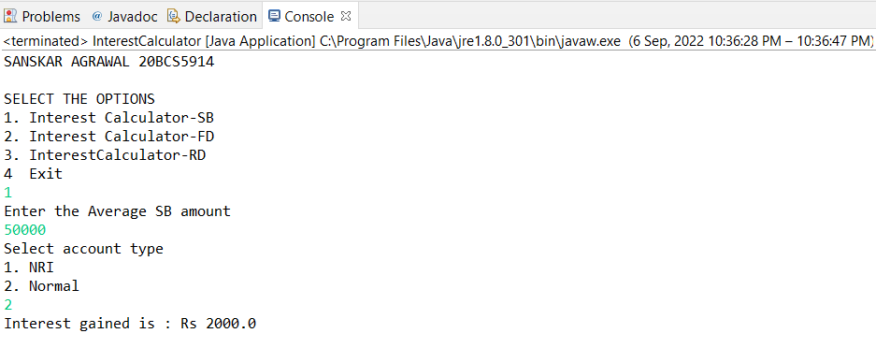

**Learning outcomes (What I have learnt):**

1. Familiar with Environment
2. Basic functions to perform on array and linked list
3. Uses of abstract class and inheritance
4. Uses of switch case

**Evaluation Grid:**

|  |  |  |  |
| --- | --- | --- | --- |
| Sr. No. | Parameters | Marks Obtained | Maximum Marks |
| 1. | Student Performance (Conduct of experiment) objectives/Outcomes. |  | 12 |
| 2. | Viva Voce |  | 10 |
| 3. | Submission of Work Sheet (Record) |  | 8 |
|  | Total |  | 30 |